Dear Friend,
As you read this letter from me, you are probably either in one of three situations. The first one is that you are questioning, “who is Jesus, does he love me, and does He have a plan for my life?” If that is you, I want you to know that I can say with full confidence that He does. No matter what lies in your past He wants to have a personal relationship with you, and He desires to come into your heart and bring you hope for the future. If you realize that you are without hope, and want to be forgiven for the sin in your life, just take some time now and sincerely repeat this prayer in your heart.
Dear Jesus, I realize that I am a sinner, and that I need you. Thank you for dying for me on the cross. I ask you to forgive me and make me whole. Please come into my heart and be my Lord. I give you my life and ask you to take full control from this moment on. Lead me home to Your Kingdom, guide me to focus on GOD’s Will not my own understanding; I pray this in the name of Jesus Christ." Amen
If you just prayed this prayer, congratulations! This is the most important decision that you could ever make in your life. Contact us any time to discuss helpful things that will guide you in your new life with Jesus. We want to help you as much as we can & we are here for you in this journey!
For those of you in the second group, you may have prayed this prayer at one of our concerts or in the recent past and you are wondering “now what?” Please take some time to read through the things in this site to help you as you go forward as a new believer in Jesus.
For those in the third group, you may have prayed this prayer or attended a church at one point & find that you have gotten away from the beliefs. Or you may have been in a situation that made a way for you to abandon those beliefs. You may even have been in a church that forsook the teachings of Christ, preferring to take the worldly course of self glorification. These things were prophecies of Jesus Christ himself to happen. However, you are not alone. GOD our Father still loves you. He will accept you back “home” when you are ready. Please take some time to read through the things in this site to help you as you return to your faith & build it even stronger in Christ than before.
Either way I want to encourage you all, that you have reached a turning point in your life and it’s time to look forward. Don’t be talked into looking back at your old life, rather see what God has done for you and embrace the new hope that you now have with Jesus Christ in your heart. He won’t ever leave you and wants to walk with you daily.
You are loved,
5 FIRST STEPS
(For More Info on Each Topic, Click the Pictures or the hyperlinks in blue)
Pray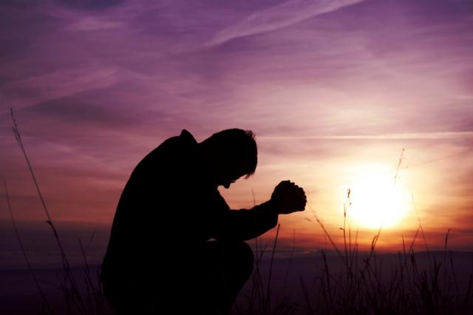
When we start a new friendship with someone, we want to try and get to know as much about them as possible. Prayer helps us get to know more about God and let's us talk directly to Him!
This is what we call our RADIO COMMUNICATIONS! It’s a military concept of talking to our Tactical Operations Center which is GOD’s Kingdom!

Read the Bible
Think of the Bible as God's love letter to you! He wants us to find out what He has to say to us about life, and the Bible shows us how to build our faith in God, trusting Him to help us live the best life that we can.
In this concept, we have titled the bible under the acronym S.W.O.R.D., which is Standard Weapon Of Righteous Deliverance! We are more than happy to provide a copy in whichever version you need & have an abundance of KJV.
We carry them in a variety of sizes as well titled in military fashion:
- RIFLE
- PISTOL
- GRENADE
- MACHINEGUN
If you have need of a bible allow us to be you’re A.R.M.S. DEALER today!

Find Strong Friends
Friends who want to help us get closer to God are so awesome! We were never meant to walk through life alone! God has a BIG family that you are now part of, and He wants us to help each other!
You have many friends in the Kingdom. GOD will place you with who He has for you to elevate your faith, for your growth. We at 1LOVE VAULT Ministries are always welcome, available & glad to be a friend for you when you need.
Let God Make You Brand New!
When God comes into our life, we will never be the same! (2 Corinthians 5:16-17) Let Him help you get rid of all the stuff from your "old life" that would keep you from growing close to Him!

Find A Good Christian Church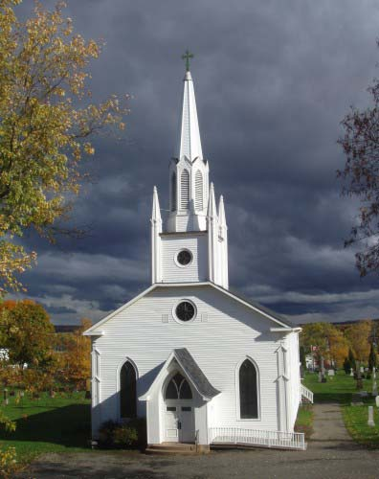
Getting involved in church is very important. It's where you can find the friends and support you need to make sure you stay on track!
Understand though, the church is the Bride of Christ & it is in people, not a building. All the building can provide is a meeting place for the fellowship of the people in Christ. A building cannot hold you accountable in you faith to GOD, nor can it save you from that fiery lake! A good church means one where accountability & leadership abound from the youngest to the oldest, the lowest on staff to the highest on staff. This is the way Jesus taught it (ie to serve, not be served) & how the Apostles expanded on it from the day of Pentecost on afterward.

